**VISVESVARAYA TECHNOLOGICAL UNIVERSITY**

"Jnana Sangama", Belgaum: 590 018

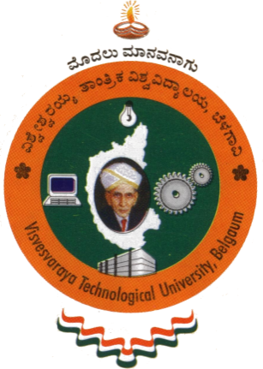

A Mini Project report on

**“CLOCK”**

Submitted in partial fulfillment of the requirement for the award of Degree of

**BACHELOR OF ENGINEERING**

**IN**

**COMPUTER SCIENCE AND ENGINEERING**

By

**DHRUVA M (**1AY10CS017**)**

Under the guidance of

**Prof. SUREKHA K B Prof. VANI K S**

**Prof. NARASIMHA MURTHY M S Prof. SRINIVASULU M**

Assistant Professors

Department of Computer Science & Engineering



**DEPARTMENT OF COMPUTER SCIENCE & ENGINEERING**

**ACHARYA INSTITUTE OF TECHNOLOGY**

(Affiliated to Visvesvaraya Technological University, Belgaum)

**2012-2013**